**Console Baking**

1. Open command prompt set path to php i.e. where php.exe file is present and cakephp where cake.bat file is present. We can set path permanently or temporally.
2. Go to project app folder

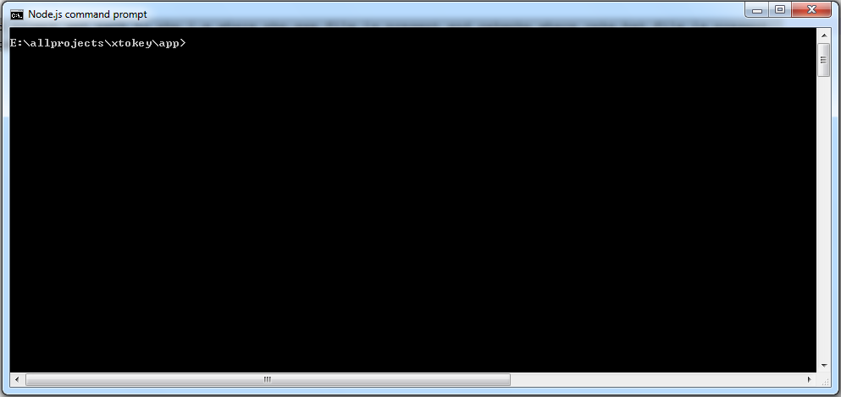

1. Set Path to php and cakephp as below (Here using temporary path setting)

set PATH=%PATH%;D:\xampp\php;E:\allprojects\2015\yourproject\app\Console

1. Now type **cake bake** in the console to check if cakephp console baking command working or not.
2. Use **cake bake all** to bake everything for a table i.e. it will generate model, view and controller for that table.
3. We also can bake specific module like only model use command **cake bake model**

**Speed Optimization**

Minimize HTTP Requests

**Combined files**

**CSS Sprites**

**Image maps**

**Inline images**

Use a Content Delivery Network

Add an Expires or a Cache-Control Header

Put Stylesheets at the Top

### Put Scripts at the Bottom

### Avoid CSS Expressions

### Make JavaScript and CSS External

### Reduce DNS Lookups

### Minify JavaScript and CSS

### Avoid Redirects

### Remove Duplicate Scripts

### Configure ETags

### Make Ajax Cacheable

### Flush the Buffer Early

### Use GET for AJAX Requests

### Post-load Components

### Preload Components

### Reduce the Number of DOM Elements

### Split Components Across Domains

### Minimize the Number of iframes

### No 404s

### Reduce Cookie Size

### Use Cookie-free Domains for Components

### Minimize DOM Access

### Develop Smart Event Handlers

### Choose <link> over @import

### Avoid Filters

### Optimize Images

### Optimize CSS Sprites

### Don't Scale Images in HTML

### Make favicon.ico Small and Cacheable

### Keep Components under 25K

### Pack Components into a Multipart Document

### Avoid Empty Image src

### https://developer.yahoo.com/performance/rules.html